\

BEAUFORT WEIGHBRIDGE BUILDING

Relocation of the weighbridge building at the Mechanics Institute site in Havelock Street, Beaufort.

Council has received a request to consider relocating the small weighbridge building located at the Beaufort Mechanics Institute site, to a location where it can be appropriately maintained and enjoyed by the public.

The building was built by the Shire of Ripon in 1874 to house the weighbridge scale (the two lamps being added in 1885) and sited where the band rotunda now stands. Moved in 1903, it became a storage shed for Wotherspoon Bros, and in the 1950’s a shelter for visitors to the Beaufort Cemetery. Later it was relocated to Main Lead as a tool shed where is remained until 2005, when it was donated back to the people of Beaufort by Cellante Family. Finally restored, it was located to its current site in November 2008.

Council would like to receive feedback from the community with suggested alternate sites for the building.

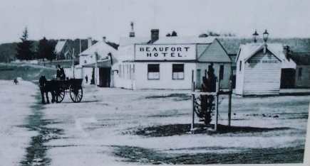

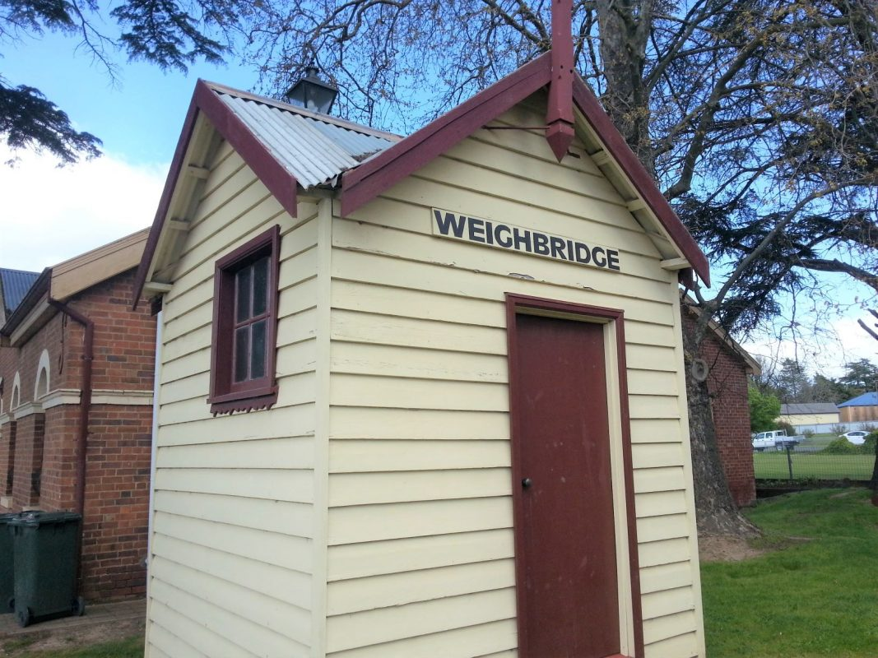
Photos from Destination Beaufort website http://www.destinationbeaufort.com.au/listings/weighbridge/
BEAUFORT WEIGHBRIDGE BUILDING RELOCATION

SHARE YOUR FEEDBACK

Name (optional):
Where do you think the weighbridge building should be located to?
Why do you think this?
Do you have any other comments?

The survey is available online on Council’s website: www.pyrenees.vic.gov.au. Please call Council if you would like a printed copy posted. Paper copies can be picked up at Council’s Customer Service Centre, 5 Lawrence St, Beaufort or Avoca Information Centre, 122 High St, Avoca when the centres have re-opened to the public.

Please complete the survey and either:
- Email to pyrenees@pyrenees.vic.gov.au
- Mail to Pyrenees Shire Council, 5 Lawrence St, Beaufort Vic 3373
- Drop off at the Customer Service Centre 5 Lawrence St, Beaufort or Avoca Information Centre, 122 High St, Avoca.
This survey closes Friday 8 October 2021

If you have any questions about this project please call 1300 797 363.

